Did you know? Without greenhouse gases, the Earth’s surface would be frozen!
Name: ____KEY_________________
Science TEKS: 3.6, 3.11, 4.6, 5.2, 5.3, 5.4, 5.5

Math TEKS: 5.11, 5.14, 5.15

Lesson Six:
Climate Change

What will we be learning about today?
Today, you will be taking your last GLOBE measurements – measuring the amount of tropospheric ozone in the air, the type of cloud cover, the surface and air temperature, wind direction, and humidity.
We are going to learn about global warming, which occurs when Earth’s climate becomes warmer. Certain gases in the atmosphere, like carbon dioxide, are called greenhouse gases because they trap in Earth’s warmth. Without them, most of Earth’s surface would be frozen. However, emitting more of these gases to the atmosphere can contribute to global warming. You will learn about some of the possible impacts of global warming today.
Energy efficiency and alternative sources of energy can help reduce emissions of greenhouse gases. For example if cars can use gasoline more efficiently, less air pollutants and greenhouse gases will be released into the air.
You will also be able to calculate your “carbon footprint.” A carbon footprint tells you how much carbon dioxide is emitted as a result of your day‐to‐day actions. It can also tell you how you could change your actions so that fewer pollutants are released into the air.
Interactive Map: Global Warming Impacts

1. Go to www.nationalgeographic.com. Click on “Environment” on the left-hand side of the screen. Then click on the “Effects of Global Warming,” found in the dark green box entitled “Environment Topics.” Scroll down and click on “Interactive: Map of Impacts.”
(The direct link is: http://environment.nationalgeographic.com/environment/global-warming/gw-impacts-interactive.html )

2. You should see a world map on the screen. On the map, you can see the effects global warming can have around the world if the climate continues to warm. Mark and write down three effects that you find interesting on the map below.
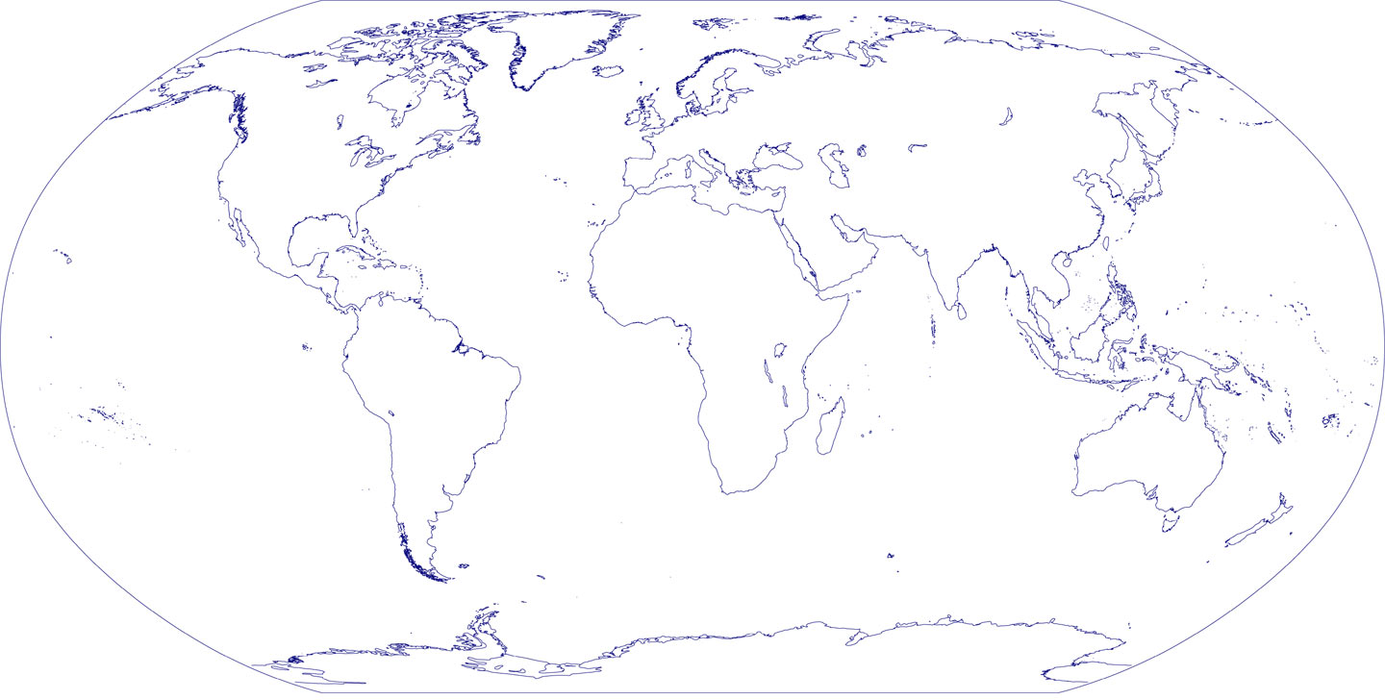

Click on one of the impacts to go into more detail. What does it say?
_____Answers may vary__________________________
___________________________________________________________________________________________________________

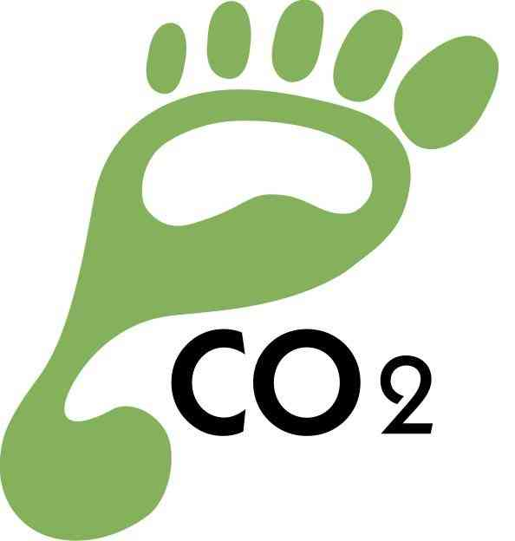
Measuring Your Carbon Footprint

1. Go to www.epa.gov/climatechange/kids/calc/index.html
2. Follow the instructions on the screen, and answer the questions that pop up.
3. On each screen, you can answer “Yes” if you will take that action, “No” if you will not, or “I already do this” if you are already taking this action. You can learn about each action by following the “Find out more” link.
4. When you have completed answering all of the questions, “Your Summary” will come up on the screen. Fill in the blanks with your results:

Based on what you're already doing, you're avoiding ___________lbs of CO₂ per year.
This is equivalent to the emissions from driving a car ___________ miles.

If you take the additional actions that you checked above,
you will avoid another ___________lbs of CO₂ per year.
This is equivalent to the emissions from driving a car ___________ miles.

Make a list of actions you could take to reduce your carbon footprint.
Circle the actions that you think are most realistic to achieve.
1.
2.
3.
4.
5.

